


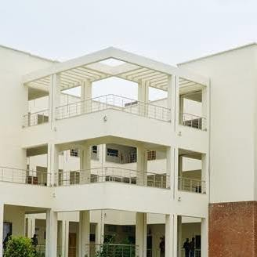
GROUP MEMBERS:
SUBMITTED TO: MS. MINA

DSA LAB

- Aneela Sarwar FA24-BCS-182
- M Okasha FA24-BCS-187
- Maheen Akhtar FA24-BCS-198
- Hassan Arshad FA24-BCS-199
Comsats University, Islamabad (Sahiwal Campus)
DSA LAB

Data Structure Planning Table – Snake Game

Operation | Data Structure Used | Reason
Add new head when snake moves | Linked List | Fast insertion at head (O(1))
Remove tail when snake moves without eating | Linked List | Simulates snake movement
Store row and column of each body part | Node Structure | Stores position of each segment
Place and update food position | Variables | Only one food needed
Change snake direction on key press | Variables | Direction stored in dr, dc

Pseudocode – Snake Game Functions
Function 1: insertHead(r, c)
- Create new node with row = r and col = c
- Set new node's next = head
- Update head = new node
- If tail is NULL, set tail = new node
Function 2: removeTail()
- If head or tail is NULL, return
- If head == tail, delete and set both to NULL
- Else, find second last node
- Delete last node and update tail
Function 3: handleInput()
- If key pressed, read it
- W, S, A, D change direction
Function 4: moveSnake()
- Calculate new head position
- Check for wall and self collision
- Insert new head
- If food eaten, increase length
- Else remove tail
Function 5: placeFood()
- Generate random row and column
GitHub Page:
https://github.com/MuhammadOkasha/DSA_Project

